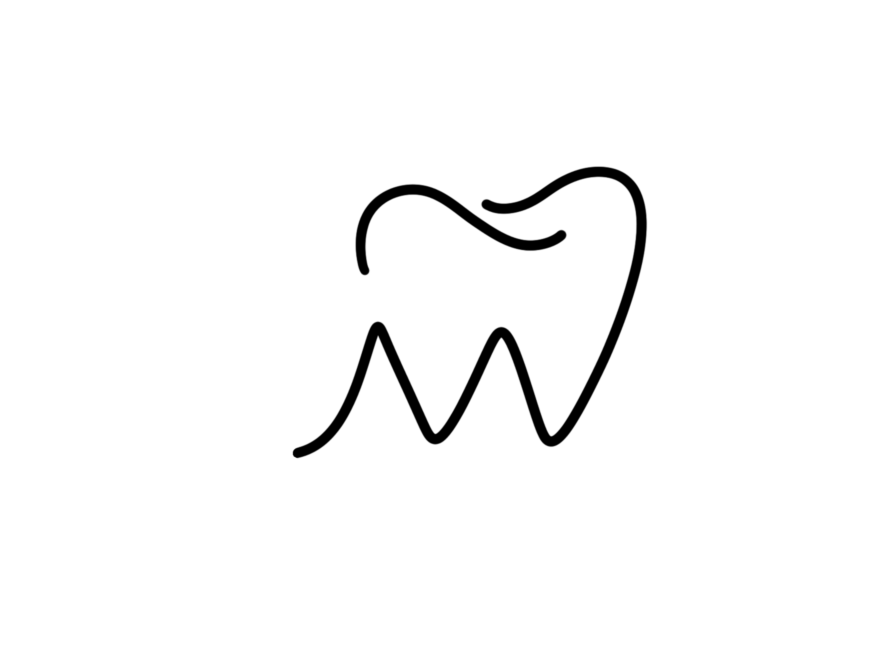

**Botox PRE - TREATMENT INSTRUCTIONS**

In an ideal situation it is prudent to follow some simple guidelines before treatment that can make all the difference between a fair result or great result, by reducing some possible side effects associated with the injections. We realize this is not always possible; however, minimizing these risks is always desirable.

* Patient must be in good health with no active skin infections in the areas to be treated
* Patient should not be needle phobic
* Avoid alcoholic beverages at least 24 hours prior to treatment. Alcohol may thin the blood which will increase the risk of bruising.
* Avoid anti-inflammatory / blood thinning medications ideally, for a period of two (2) weeks before treatment. Medications and supplements such as Aspirin, Vitamin E, Gingo Biloba, St. John’s Wort, Ibuprofen, Motrin, Advil, Aleve, Vioxx, and other NSAIDS are all blood thinning and can increase the risk of bruising/swelling after injections.
* Schedule Botox® appointment at least 2 weeks prior to a special event which may be occurring, i.e., wedding, vacation, etc. etc. It is not desirable to have a very special event occurring and be bruised from an injection which could have been avoided.

**Botox POST - TREATMENT INSTRUCTIONS**

The guidelines to follow post treatment have been followed for years, and are still employed today to prevent the possible side effect of ptosis (drooping of the eyelids). These measures should minimize the possibility of ptosis.

* No straining, heavy lifting, vigorous exercise for 3-4 hours following treatment. It is now known that it takes the toxin approximately 2 hours to bind itself to the nerve to start its work, and because we do not want to increase circulation to that area to wash away the Botox® from where it was injected.
* Avoid manipulation of area for 3-4 hours following treatment. (For the same reasons listed above.) This includes not doing a facial, peel, or micro-dermabrasion after treatment with Botox®. A facial, peel, or micro-dermabrasion can be done in same appointment only if they are done before the Botox®.
* Facial exercises in the injected areas is recommended for 1-hour following treatment. This is to stimulate the binding of the toxin only to the localized area.
* It can take 2 -10 days to take full effect. It is recommended that the patient contact the office no later than 2 weeks after treatment if desired effect was not achieved and no sooner to give the toxin time to work.Makeup may be applied before leaving the office.