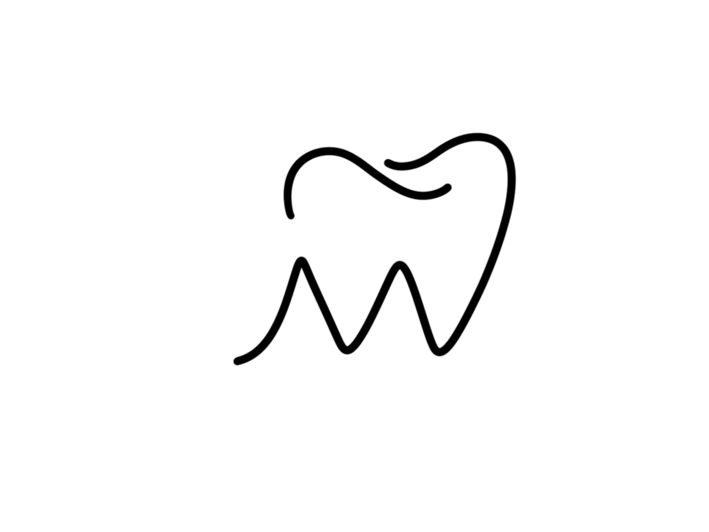

**Oral Surgery and Dental Extractions Informed Consent Treatment:**

Treatment: ______________________________________________________________________

I understand that oral surgery and/or dental extractions include inherent risks such as, but not limited to the following:

1. **Injury to the nerves:** This would include injuries causing numbness of the lips, the tongue, and any tissues of the mouth and/or cheeks or face. The numbness which could occur may be of a temporary nature, lasting a few days, a few weeks, a few months, or could possibly be permanent, and could be the result of surgical procedures or anesthetic administration.

2. **Bleeding, bruising, and swelling.** Some moderate bleeding may last several hours. If profuse, you must contact us as soon as possible. Some swelling is normal, but if severe, you should notify us. Swelling usually starts to subside after about 48 hours. Bruises may persist for a week or so.

3. **Dry Socket:** This occurs on occasion when teeth are extracted and is a result of a blood clot not forming properly during the healing process. Dry sockets can be extremely painful if not treated. These usually develop 3-4 days after the surgery.

4. **Sinus involvement.** In some cases, the root tips of upper teeth lie in close proximity to sinuses. Occasionally during extraction or surgical procedures the sinus membrane may be perforated. Should this occur, it may be necessary to have the sinus surgically closed. Root tips may need to be retrieved from the Sinus.

5. **Infection.** No matter how carefully surgical sterility is maintained, it is possible, because of the existing non-sterile oral environment, for infections to occur post-operatively. These may be of a serious nature. Should severe swelling occur, particularly accompanied with fever or malaise, professional attention should be received as soon as possible.

6. **Fractured jaw, roots, bone fragments, or instruments:** Although extreme care will be used, the jaw, teeth toots, bone spicules, or instruments used in the extraction procedure may fracture or be fractured requiring retrieval and possibly referral to a specialist. A decision may be made to leave a small piece of root, bone fragment, or instrument in the jaw when removal may require additional extensive surgery, which could cause more harm and add to the risk of complications.

7. **Injury to adjacent teeth or fillings:** This could occur at times no matter how carefully surgical and/or extraction procedures are performed. 8. Bacterial Endocarditis: Because of normal existence of bacteria in the oral cavity, the tissues of the heart, as a result of reasons known or unknown, may be susceptible to bacterial infection transmitted through blood vessels, and Bacterial Endocarditis (an infection of the heart) could occur. It is my responsibility to inform the dentist of any heart problems known or suspected or of any artificial joints I may have.

9. **Unusual reactions to medications given or prescribed:** Reactions, either mild or severe, may possibly occur from anesthetics or other medications administered or prescribed. All prescription drugs must be taken according to instructions. Women using oral contraceptives must be aware that antibiotics can render these contraceptives ineffective. Other methods of contraception must be utilized during the treatment period.

10. It is my responsibility to seek attention should any undue circumstances occur postoperatively and I shall diligently follow any pre-operative and post-operative instructions given to me.

**Informed Consent** As a patient, I have been given the opportunity to ask any questions regarding the nature and purpose of surgical treatment and have received answers to my satisfaction. I do voluntarily assume any and all possible risks, including the risk of harm, if any, which may be associated with any phase of this treatment in hopes of obtaining the desired results, which may or may not be achieved. No guarantees or promises have been made to me concerning my recovery and results of the treatment to be rendered to me. The fees for this service have been explained to me and are satisfactory. By signing this form, I am freely giving my consent to allow and authorize Dr. Haley Miller and his associates to render any treatments necessary or advisable to my dental conditions, including any and all anesthetics and/or medications.

Name of Patient ______________________________________________________________________

Signature of Patient & Date

____________________________________________________________________

Signature of Doctor & Date ____________________________________________________________________