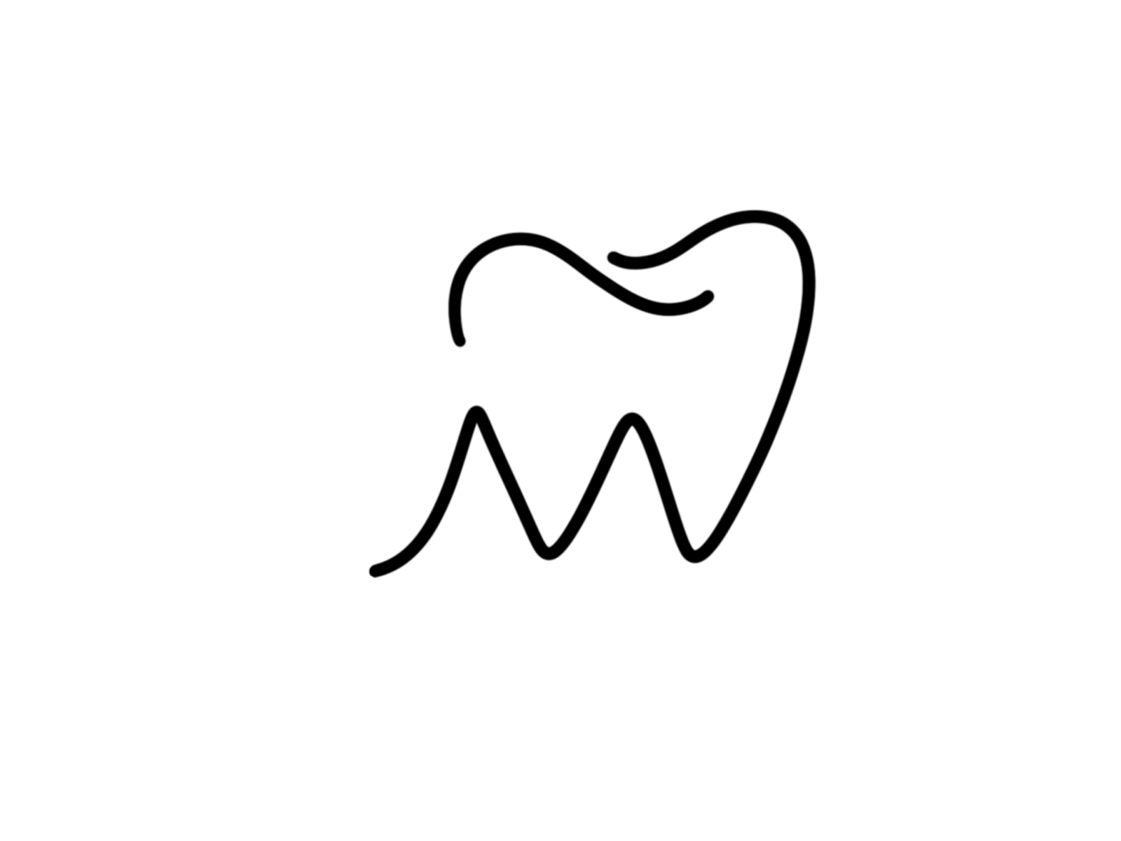

DENTURE CONSENT FORM

Haley Miller, DDS

We believe it is very important for our patients to be well-informed and be fair in their expectations BEFORE we begin treatment. All dental prostheses carry certain risks and limitations that you should be aware of. Please read the following carefully, ask any questions that you may have, and sign below to give us consent to proceed with the treatment.

_____ 1. Dentures have ~20% of the chewing efficiency of natural teeth. Because of this you may not be able to eat certain foods very well. Common examples are steak and corn-on-the-cob.

_____ 2. Denture fabrication typically involves ~4 appointments which can take up to 6 weeks or more, so your patience in this process is a **must**.

_____ 3. Every patient will need time and effort to adapt to their dentures. **Dentures will be uncomfortable at first and will usually require several adjustments until they are comfortable.** Every patient will need to re-learn chewing and speech in order to use their dentures effectively.

_____ 4. After delivery of the dentures, we cover free adjustments at a **limit of two within the first six months;** these adjustments will not exceed one soft reline and do not include lab procedures such as hard relines, rebasing the denture, etc. Any more than two adjustments within six months, any adjustments after six months, or any adjustments involving the lab will incur a fee based on the office fee schedule.

_____ 5. **If you have had dentures before, your new dentures will be different.** This will require time to adjust to and you will need to re-learn to use them and there is always a risk that your new ones may not be as effective as your old ones.

_____ 6. Most patients have difficulty with the lower denture. Lower dentures tend to come unseated easily and are not held in place by suction. This is not a problem with the denture or how it fits. This is a problem with the muscles there and the amount of residual bony ridge present. Denture adhesive can compensate for this *to a degree* but in heavily problematic cases implants should be considered as a solution for long-term stability and retention.

_____ 7. The front teeth of a denture are for cosmetics mostly and patients are generally unable to bite very effectively with them. Therefore, **using a knife and fork and chewing with the back teeth** is the best approach for many patients.

_____ 8. The bony ridge that the denture sits on will gradually **resorb** over time and the resorption can occasionally be rapid**. Eventually the denture will need to be re-lined or re-made and this is the financial responsibility of the patient**.

_____ 9. In the event that the case requires specialist intervention due to unexpected difficulty or additionally necessary procedures, the patient will be referred to an appropriate specialist for care. Any fees incurred for the specialist will be the financial responsibility of the patient and not of our office.

_____ 10. Although our office will do everything we can and to the best of our ability, **cannot warranty any denture and offer any guwe arantees of success**. As a patient, you MUST manage and possess realistic expectations. Dentures are not and do not function like natural teeth. Our office does not refund for any services or products already rendered. This is non-negotiable under any circumstances as lab fees are sunk costs and we cannot return to the lab what's already been made.

______ 11. Lab fees are the responsibility of the patient. Our labs provide top quality dentures and charge us for such materials, try-ins, and time. By signing this agreement, you consent to be charged an additional fee *not charged to insurance* that is incurred from the lab to make your dentures.

_____ It has been explained to me and I understand that a perfect result cannot be guaranteed and there is no warranty. I have had the opportunity to ask any and all questions related to dental prostheses and my particular case. I also acknowledge my financial obligations and agree to pay for all necessary and reasonable expenses pertaining to the treatment.

Signature: _______________________________________________Date:____________

IMMEDIATE DENTURE CONSENT FORM

Haley Miller, DDS

**WHAT TO EXPECT:** Going from natural teeth to a denture is a big adjustment for any patient. The patient’s ability to chew food decreases about 90%. Taste of food and often speech may be altered at first. In general, an upper denture is easier to adjust to than a lower denture. The amount of stability of a denture depends on several things and not all people adapt to complete dentures as well as others. We will do everything in our power to help you adjust to your new dentures, however, the patient must realize that dentures are a satisfactory replacement for having no teeth at all but they very rarely function as well as natural teeth.

**APPOINTMENTS:** Your treatment will be an immediate denture: this means that your denture will be placed immediately after having your teeth extracted. The advantage of doing this is that you will never have to be without teeth. For 3-5 weeks after the delivery of your dentures, you may require follow up appointments to adjust the denture as your mouth heals and the dentures settle in. It is normal for the denture to loosen as your mouth heals. The ridges that held your teeth in before will shrink and change shape. Most of your changes will occur in the first three months and then the ridge will begin to stabilize. At the end of one month, if the denture is too loose to function properly, a temporary healing reline will be needed to refit the denture. Complete healing and reshaping of the ridge can take anywhere from 6 months to 1 year. At this point, a permanent reline, or new mandibular denture will be needed to refit the dentures.

**COST:** The cost of an immediate denture not only includes the denture but also adjustments of the denture and any temporary healing relines needed for the first three months after delivery. After this, there may be an adjustment charge depending on the individual circumstances and the time needed for the adjustment. At the end of 9 to 12 months (when the ridge has stabilized), most patients need to have a permanent reline for which there will be a separate fee.

**CONSENT:** I have read the information above and have had a chance to review and discuss my planned treatment. I understand that there is no warranty or guarantee as to any result and or cures. I understand I can ask for a full recital of any and all possible risks concerning my care by asking.

Signature: _______________________________________________Date:____________



**IMPLANT OVERDENTURE CONSENT FORM**

Haley Miller DDS

(Initials)____ With the temporary restoration only soft food should be consumed. Any food that is easy to cut with a fork is acceptable. (eggs, fish, pasta, shredded or ground meat, soup, smoothies, etc) I understand that habits such as tooth clenching, grinding and consumption of foods requiring aggressive chewing, such as jerky, nuts and tough meats, will increase the possibility of appliance damage.

(Initials)____ The temporary restoration will be in place from 4-6 months. In some situations it may be longer. It is all acrylic (plastic) and will need frequent maintenance. Tissue may change around and under the restoration. The acrylic may fracture or teeth may separate from the acrylic. All of the problems can be easily repaired but it will require time in the office.

(Initials)____ It will take some time to learn to speak and function with the new restoration. In some cases it may take 6-12 months.

(Initials)____ I understand that I have to practice daily hygiene and will follow all of the hygiene instructions given to me. The maintenance program will consist of cleaning, prosthetic screw replacement, and any required repairs. There will be a fee for this service. Usually after the first year, maintenance appointments are 2 or 3 times a year. Prosthetic screw replacement is required every 2 years on average.After delivery of the final restoration an individualized maintenance program will be established and is essential for the patient to follow.

(Initials)____ There may be a future need to replace teeth and/or acrylic due to staining, wear, or fracture. There will be a fee for this service. The appliance is stable and does not impinge upon delicate soft tissue. This causes a considerable biting force, which, in turn, increases the wear and tear on all components of the denture. This means the teeth will wear out faster or may fracture, the acrylic may crack or chip and the metal components may fatigue and crack. A cracked substructure may eventually fracture and place adverse torque on the implants, causing them to loosen and be lost.

(Initials)____ In rare instances the entire appliance may need to be remade, with or without surgery, to replace or repair damage to the implants and their supporting bone.

(Initials)____ I understand that certain medical/oral conditions increase the risk of failure of dental implant treatment. For example, smoking or tobacco use, history of smoking or tobacco use, uncontrolled diabetes, bisphosphonates, osteoporosis, and poor oral hygiene. We recommend a current physical, with in the last year, with your primary care physician.

(Initials)____ I understand that my doctor can’t promise that everything will be perfect. I understand that the treatment listed above and other forms of treatment or no treatment at all are choices I have. I have read and understand the above and give my consent to surgery and restorative treatment. I have given a complete and truthful medical history, including all medicines, drug use, pregnancy, etc. I certify that I speak, read and write English. All of my questions have been answered before signing this form. I have been told that during the treatment things may change or you may find another condition needing a procedure other than the one planned above. I authorize my doctor and his staff to use professional judgment to perform the procedure and any additional procedure that may be required. I, ______________________________, have read, understand, and initialed the above statements. Date: ________________________

Patient (print): ____________________________________________

Patient signature_____________________________________________________

Dr. Haley Miller _____________________________________________

**After Try In:**

I am satisfied with the **shape, size**, and **color** of the teeth. I am satisfied with the position of the teeth when I smile (I do not feel that too much or too little teeth are showing.) I am satisfied with position and angulation of the teeth in relation to each other. I am satisfied that my lips look natural (I do not feel that my face looks too flat or too full.) I am satisfied with the midline of the teeth (the location of the 2 front teeth.) My bite feels good and the teeth are touching on both sides of my mouth. When I speak, my teeth are not clicking together or too far apart. In general, I am pleased with this wax try-in. ______________________________