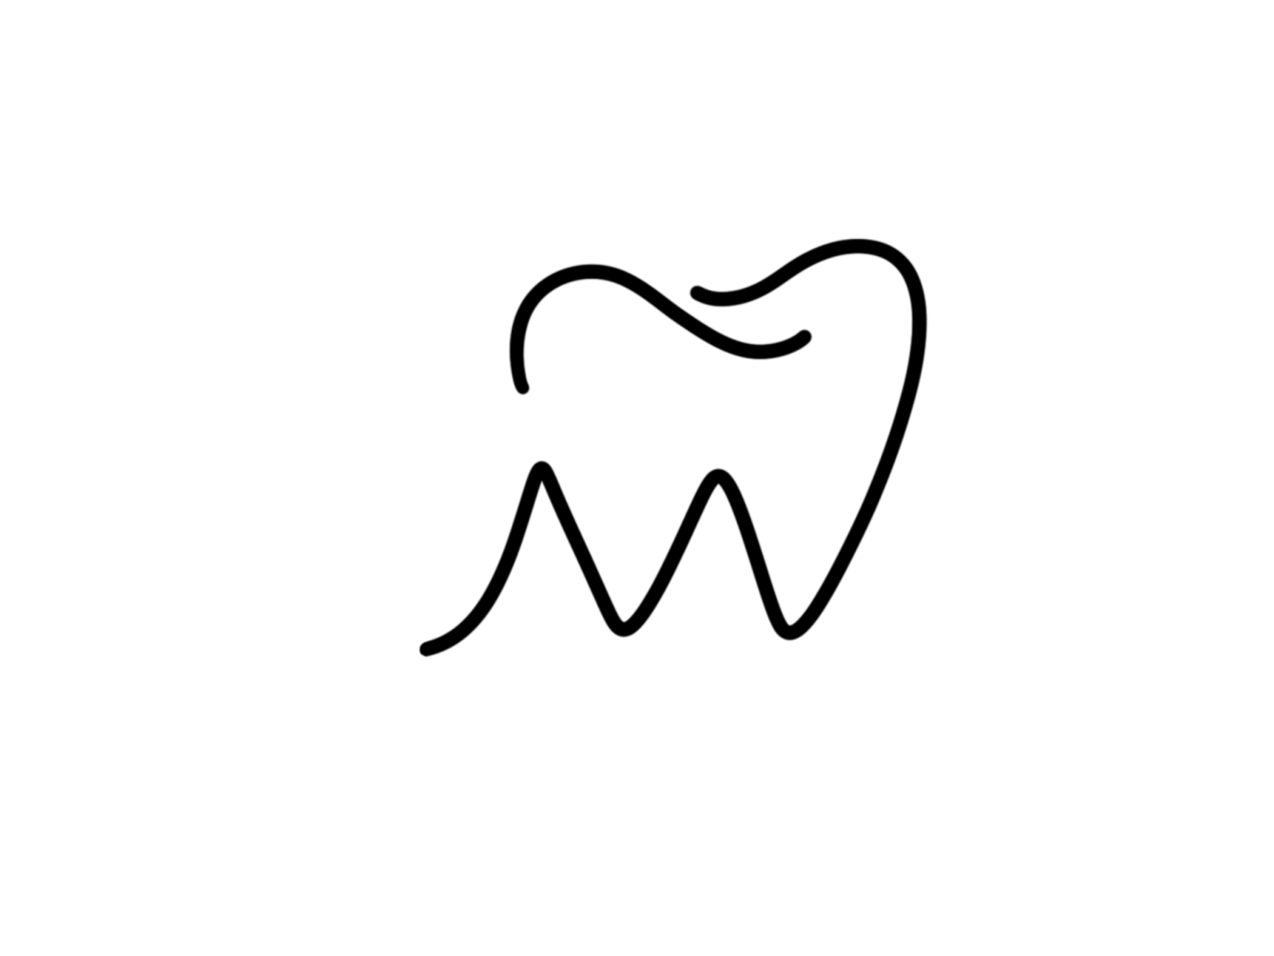

Haley Miller, DDS

**Appointment & Financial Agreement**

**Appointments:**

Appointment is reserved exclusively for you. We ask for **24 business hour** advance notice when you are unable to keep an appointment. **We reserve the right to** **charge for broken or missed appointments** and put you on a will call list If you cancel or no show without 24 business hour notice. We understand that there are circumstances that may prevent you from keeping your appointment, please provide us with as much notice as possible.

**Payments:**

Payment is due at the time services are rendered. We accept cash, checks, Visa, Master Card, Discover, American Express and Care Credit. **Cash or check** **is preferred** **because for** **all credit card transactions, a 3**% **increase will be applied to the total amount**. A fee of $ 35.00 will be charged for any checks returned by your bank. **Any unpaid balance that is over 30 days** and not paid on your account and needs additional collections you may accrued fees from outside collection.

**Insurance Benefits:**

Please familiarize yourself with your benefits and your policy. We request that you get us all your insurance information so we can help you get the benefits you deserve. We file your **Primary insurance claim as a courtesy** to you and your estimated fee is requested at the time services are rendered. **If you have two insurances, the payment from your secondary insurance will be sent to YOU.** We will send your secondary insurance company any forms that are needed to help you get your reimbursement. **NO benefits are a guarantee of paymen**t until the claim is filed after services are referenced! Your benefits are determined by your employer, not your dentist. We will do our best to **maximize** your dental benefits, however, **any dental claim 30 days outstanding not paid by your dental insurance is ultimately YOUR responsibility.**

Thank you in advance for your trust in our office to move forward with your dental appointments and financial agreement.

Name: _________________________________________________ Date: __________________________

I certify that I, and/or my dependent(s), have insurance with _______________________________ and assign directly to **Dr. Haley Miller** all insurance benefits, if any, otherwise payable to me for services rendered. I understand that I am financially responsible for all charges whether or not paid by insurance. I authorize the use of my signature on all insurance submissions.

The above named dentist may use my health care information and may disclose such information to the above-named insurance company and their agents for the purpose of obtaining payment for services and determining insurance benefits or the benefits payable for related services.

Name: _________________________________________________ Date: __________________________