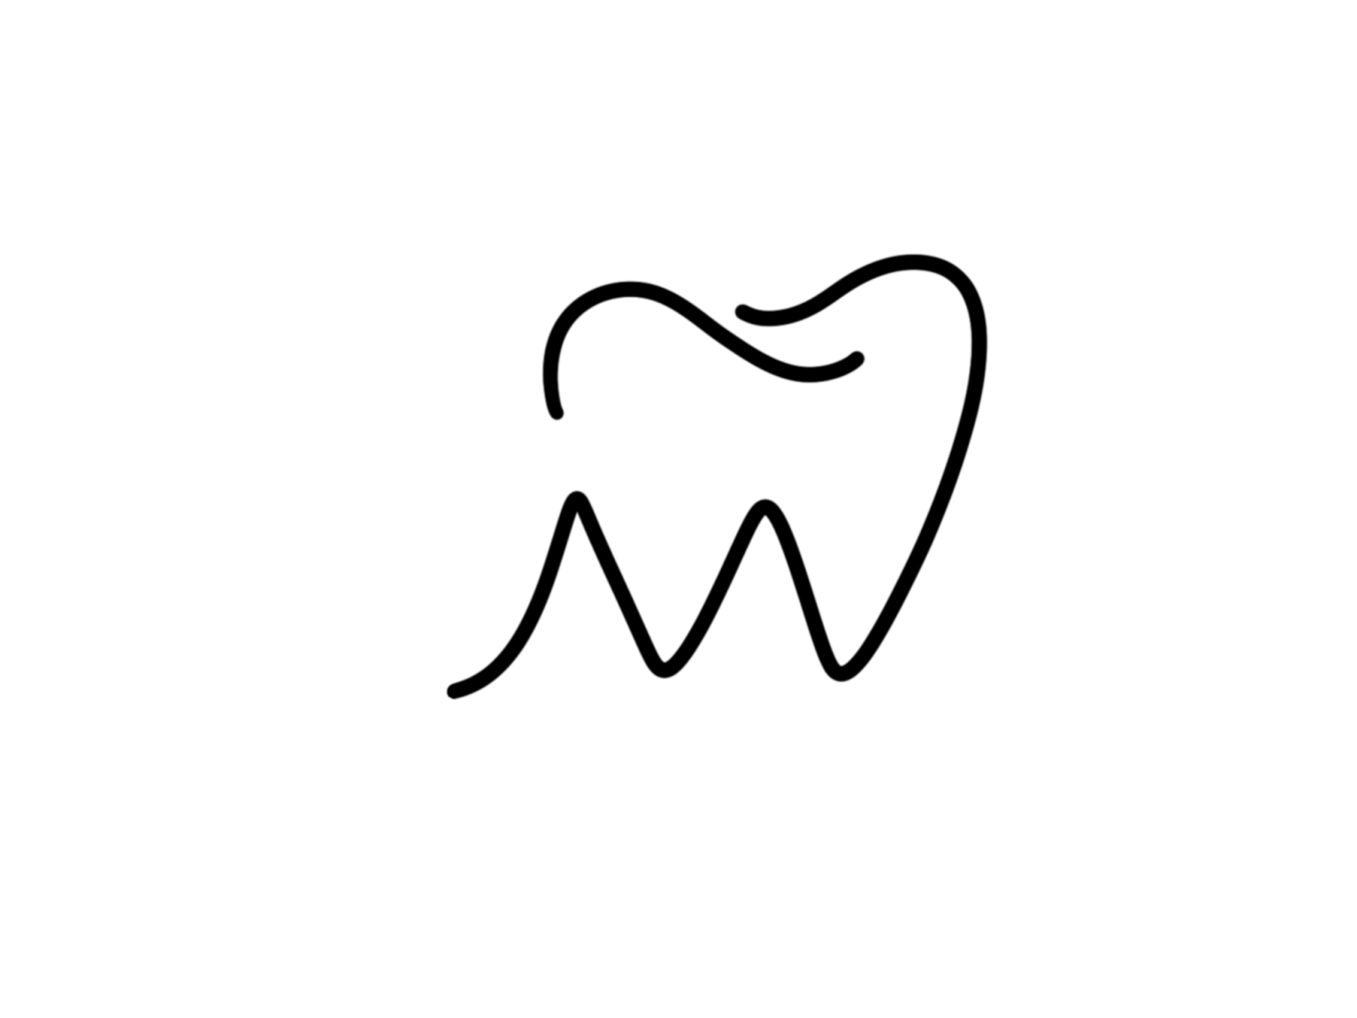

HALEY MILLER, DDS

**ANNUAL UPDATE SHEET**







